If Kondratieff was right about super-cycles, we've still got years of slump to go
By Jeremy Warner Economics March 20th, 2012

Is the current financial crisis the start of a longer downswing?
One of my earliest introductions to the world of economics came from someone who was a true believer in the Kondratieff Wave – the idea that there is a much longer cycle, lasting approximately fifty years, which overlays the ordinary, and shorter business cycle. You'll be pleased to know that if the present crisis marks the start of a classic Kondratieff downswing, then we've got between five and thirty-six years of slump still to come.

In any case, it was a delight to have my attention drawn via a reader letter to the editor to a Sunday Telegraph article, published in October 1987, which postulated that the stock market crash of that month marked the crest of a Kondratieff Wave, ergo it would therefore be downhill from then on for the next 20-30 years. Well there was a recession shortly afterwards, albeit shallow and shortlived, but thereafter, decent levels of growth resumed and continued but for another brief hiccup around the turn of the century right up to the present crisis.
Nor was this the only error in prediction. Kondratieff Waves tend to be associated with the eclipse of one world superpower and the rise of another, so it was logical to assume back then that the still apparently unstoppable rise of Japan would eventually dislodge the United States from its position of economic hegemony.

How wrong can you be?
However, none of this disproves the Kondratieff theory. The mistake made in The Sunday Telegraph article may have been merely to misread the cycle. Kondratieff, a Russian economist who died in Stalin's Gulags, identied three distinct long waves, the dates of which you can see in the table below. The downswing in the last of these waves begins during the First World War or shortly afterwards.
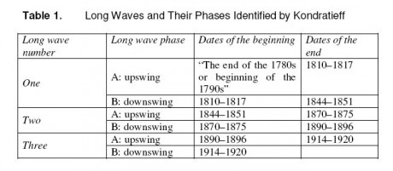
Subsequent students of Kondratieff cycles have placed the end of this third cycle during or shortly after the Second World War, which seems logical enough, and have identified a further two cycles thereafter, with the fifth upswing beginning in the 1980s and ending with the current crisis. On past durations, we are now in a downswing phase lasting anything between ten and forty one years. Dating the beginning of the crisis from 2008, that's between five and thirty six years to go.

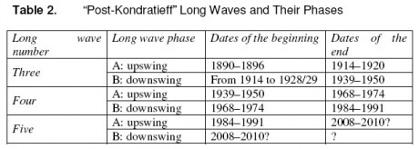

Part of the difficulty with Kondratieff is deciding precisely what the cycle is. Kondratieff himself observed the waves first in capital investment dynamics – high periods of investment followed by low periods – and then later in production of pig iron. Subsequent followers have observed the cycles in price indices, or relatively elevated periods of inflation followed by low ones. A further explanation connects them with waves of technological innovation. Kondratieff himself observed that "during the recession of the long waves, an especially large number of important discoveries and inventions in the technique of production and communication are made, which however are usually applied on a large scale only at the beginning of the next long upswing".

The Austrian economist, Schumpeter, was also a disciple of this latter explanation. Intuitively, it seems likely there is something in it. Periods of very high, transformational innovation are followed by rapid development and high investment as the new infrastructure is rolled out. The consequent increase in productively leads to big gains in living standards. But then the development phase comes to an end and there is a pause for breath before the next big thing comes along. In the modern age, there have been five or six great transformations, starting in Britain with the industrial revolution and then on to the transport revolution brought about by rail. Subsequently there was the era of electricity and the automobile, then came electronics, air travel, and televisions. The present one, perhaps now largely over, is that of mass communications.

There is quite a bit of evidence to suggest that the current financial crisis marks the start of the latest downswing and inflection point. It also correlates quite closely with the separate "40 year rule", an old piece of Wall Street folklore which has it that really serious banking crises only happen once every forty years because this is how long it takes for all institutional recollection of the last one completely to die out, allowing the new generation of banking hotheads to let rip once more.
So there you are. You pays your money and you takes your choice.

