Climate change and its causes (read page 42-51 of Edexcel AS Geography)

Is global climate change a recent short-term phenomenon or should it be seen as part of long-term process?

- What is the difference between weather and climate?
- Why is the best evidence of long-term climate change from Greenland and Antarctica?
- What evidence do ice cores store about climate change?
- What has happened to temperatures during the current interglacial (known as the Holocene)?
- Name the last four glacial periods and the last four interglacials.
- Describe the different methods climate change can be measured in the short-term (modern), medium-term (historical) and long-term.
- Explain how we can use carbon dioxide levels, the oxygen isotope record and pollen proxy records to tell us about past environments.
- Explain how we can use historic records, dendrochronology and retreating glaciers records to tell us about past environments.
- Why di the Little Ice Age and Medieval Warm Period occur? What evidence do we have of these events?
- Why can we not rely on evidence such as the grape harvest records in the Burgundy region? What other factors other than the climate might affect grape yields?
- Explain the role oceans have in climate regulation.
- Describe temperature change over the last 150 years, see figure (a).
- What does the instrumental record tell us about climate change?
- Describe the theory Milankovitch came up with in 1924.
- Describe the difference between positive and negative feedback loops and give a climatic example of both.
- For each of the drivers of climate change, describe how they make the temperature warmer or cooler.
- Complete review Questions 1-4 on page 51.
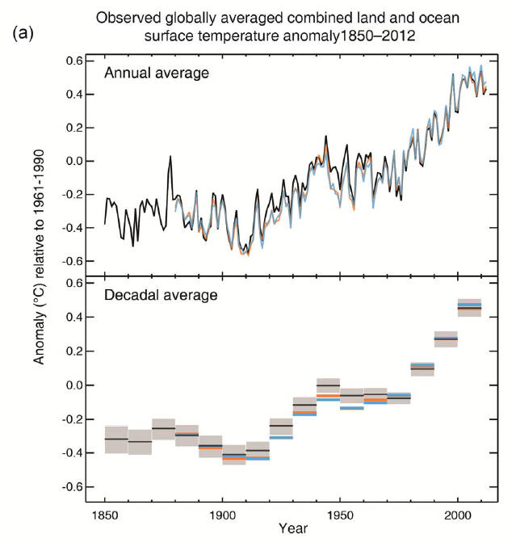

IPCC report findings 2013

Each of the last three decades has been successively warmer at the Earth’s surface than any preceding decade since 1850. In the Northern Hemisphere, 1983–2012 was likely the warmest 30-year period of the last 1400 years

Over the last two decades, the Greenland and Antarctic ice sheets have been losing mass, glaciers have continued to shrink almost worldwide, and Arctic sea ice and Northern Hemisphere spring snow cover have continued to decrease in extent

The rate of sea level rise since the mid-19th century has been larger than the mean rate during the previous two millennia (high confidence). Over the period 1901–2010, global mean sea level rose by 0.19m

The atmospheric concentrations of carbon dioxide (CO2), methane, and nitrous oxide have increased to levels unprecedented in at least the last 800,000 years. CO2 concentrations have increased by 40% since pre-industrial times, primarily from fossil fuel emissions and secondarily from net land use change emissions. The ocean has absorbed about 30% of the emitted anthropogenic carbon dioxide, causing ocean acidification

Changes in the global water cycle in response to the warming over the 21st century will not be uniform. The contrast in precipitation between wet and dry regions and between wet and dry seasons will increase, although there may be regional exceptions

