The Global Distribution of Energy Resources

page 12 of Digby et al.
Examining the global distribution of fossil fuel resources, and renewable potential

Energy security requires a country to have a range of energy supplies; control over both energy supplies and prices and political stability. Energy security can be improved by greater energy efficiency and self-sufficiency, decentralization of energy production and short-term stockpiles.
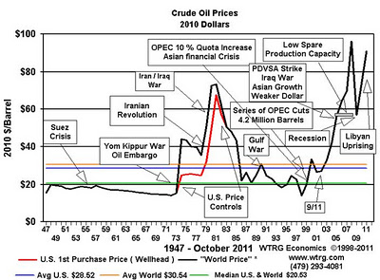

In 1973-74 the first major oil shock hit the world. This oil crisis followed years of acrimonious negotiations between members of the Organization of Petroleum Exporting Countries (OPEC) and western oil companies over petroleum production and pricing levels. Arab members of OPEC, in response to the outbreak of the Yom Kippur War, raised the posted price of crude by 70% and placed an embargo on exports to the U.S. and other nations. The United States started a Strategic Petroleum Reserve in 1975 after oil supplies were cut off during the 1973-74 oil embargo, to mitigate future temporary supply disruptions. The United States now imports a net 12 million barrels (1,900,000 m³) of oil a day, so the reserve holds about a 58-day supply. However, the maximum total withdrawal capability from the SPR is only 4.4 million barrels per day, making it a 160 + day supply.

Over to You:
- List the top three countries in terms of the reserves of finite oil, coal and natural gas.
- Uranium mining is the process of extraction of uranium ore from the ground. The worldwide production of uranium in 2011 topped 64,402 tonnes. Kazakhstan, Canada, and Australia are the top three producers and together account for 64 per cent of world uranium production. Australia produced 11 per cent of global supply and yet has... no nuclear power plants. Explain why you think the government has reservations about the nuclear industry?
- List the countries that appear in more than one top ten table for any resource. What other factors might still make these countries energy insecure?
- Describe how Masdar City has increased energy efficiency in both the construction and energy sectors.
- The price of oil peaked at $147 dollars a barrel in July 2008. How does oil price impact on the cost of food?
- Explain how the Strategic Petroleum Reserve benefits American citizens.
- How else is America ensuring itself an energy secure future?

