Global energy supply and demand

Examining trends in global energy supply and demand by source, type or economy and economic sector, especially in developed and emergent economies such as China and India

It is important to note that the use of energy in all countries has changed over time due to:
- Technological developments - Nuclear power has only been available since 1954
- Increasing national wealth - Incomes increase resulting in greater use of energy
- Changes in demand - Britain’s trains were powered by coal, now they use electricity
- Changes in price - Electricity production in UK switched from coal to gas power as gas is cheaper to run
- Environmental factors/public opinion - Can influence decisions made by governments

Global energy demand is projected to increase by 60% in the next 25-30 years as developing countries industrialise and rich countries continue to guzzle power, according to the International Energy Agency. Fossil fuels will continue to dominate, accounting for 85% of new demand. Carbon emissions are set to increase by 60%. As developing countries' share of world energy demand surges from 38% to a predicted 48%, these countries are expected to contribute two-thirds of the projected increase in carbon emissions. By 2030, renewable sources (not including biomass and nuclear) will have increased only 1% from 3% to 4% of total world use. However, costs for most types of renewable energy are expected to decrease.
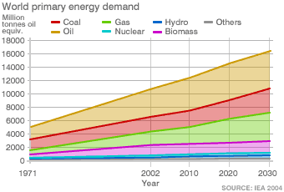
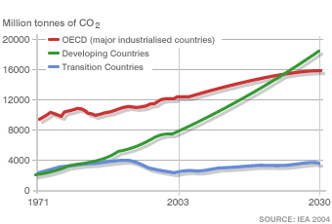
Over to you:
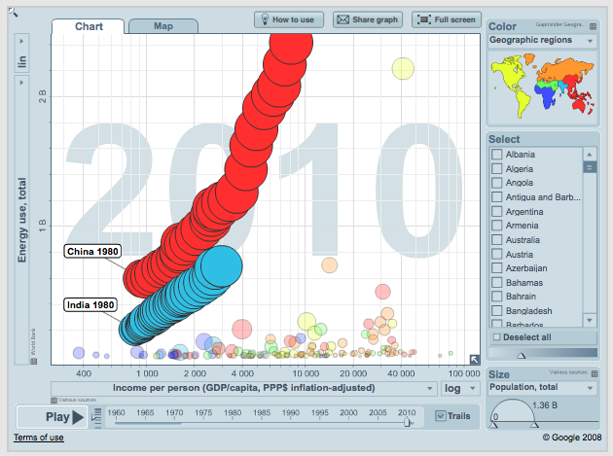
1. Describe the reasons why energy demand doubled between 1960 and 1980.
2. Where in the world are the largest reserves of coal? How will this impact on energy security and carbon emissions over the next couple of decades?
3. Using data from the World Bank, create a graph to show global energy use, describe the data you have presented. http://data.worldbank.org/indicator/EG.USE.PCAP.KG.OE
4. Use gapminder.org to create scatter graphs to show wealth against energy use and wealth against carbon emissions. How do these graphs change through time? Add trails for India and China and describe how energy use has changed over time.
5. Compare and contrast energy use per sector for the UK, China and India.

Definitions:
Energy surplus - When a country or region has more than enough sources of power for its needs and is able to export its surplus power to other countries
Energy poverty - When a country or region has insufficient access to reliable sources of power

